






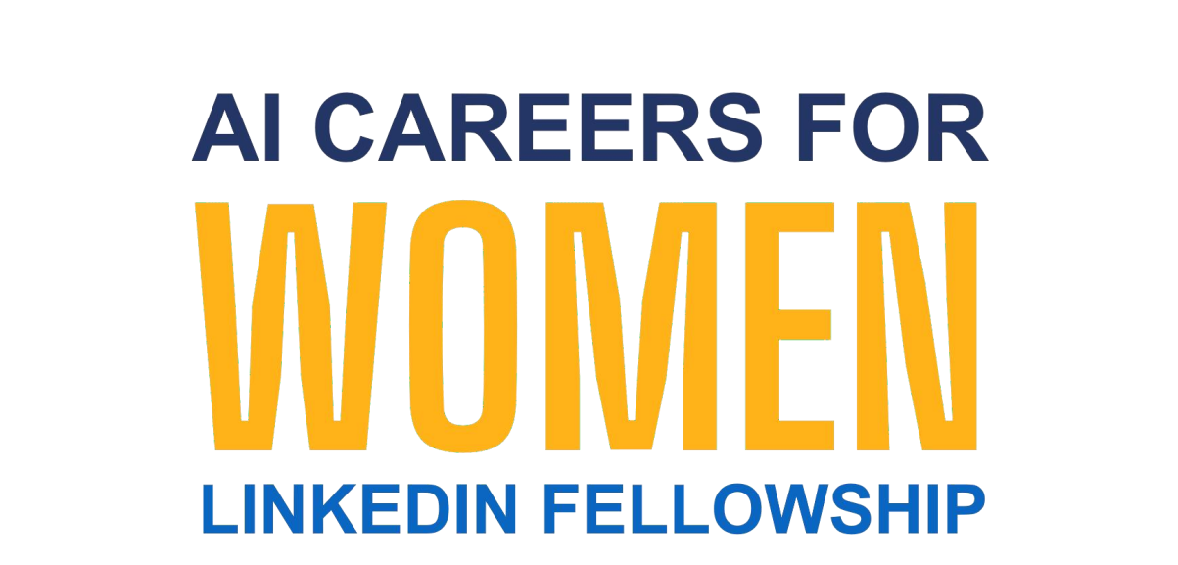




Student Name
Priyanshi Mishra
Student Email
Priyanshi.mishra07082006@gmail.com
Guide
Umamaheshwari

Starbucks Data Analytics

Project Domain
Power BI /Excel/Copilot

A Collaborative Initiative
equipping students with practical skills in AI, Data Analytics, and Business Intelligence
by:

Institution:
National Post Graduate College

Year - 2026

Problem Statement
Organizations across industries collect large volumes of data on a daily basis. However, this data is often raw, inconsistent, incomplete, or poorly structured, making it difficult to derive meaningful insights. Decision-makers rely on accurate, clean, and well-visualized data to make informed choices, but without the right tools and skills, this data remains underutilized.
Additionally, the rapid growth of Artificial Intelligence and Generative AI tools such as Microsoft Copilot and AI Chatbots has created both an opportunity and a skills gap.
Professionals who can effectively use these tools through well-structured prompts can significantly accelerate their work. However, most users lack the knowledge of prompt engineering techniques needed to unlock the full potential of these AI tools.
This project addresses these challenges by applying data cleaning, analysis, visualization, and AI integration techniques using industry-standard tools. The project will demonstrate how structured data workflows combined with AI assistance can produce accurate, actionable insights and outputs relevant to a chosen real-world domain.
  - Most dashboards only track money spent. They don't track Loyalty Quality. A student might visit only when there is a BOGO (Transactional), while a professional visits every morning regardless of offers (Emotional).
  - Data Inconsistency: Raw transaction logs are often messy, containing missing values and duplicated events that lead to inaccurate business conclusions.
  - Operational Inconvenience: Manually sorting through 300,000+ rows of data to find specific trends (like how income affects coffee preferences) is slow, exhausting, and prone to human error.
  - Lack of Personalization: Because the data is so hard to process, companies fall back on "generic" marketing, causing customers to ignore notifications that aren't relevant to them.
  - Complexity Gap: There is a significant gap between having "Big Data" and having "Useful Insights" that a manager can actually act upon quickly.
  - The Issue: Starbucks collects millions of transaction points, but without proper visualization, it’s difficult for managers to see which offers actually drive profit.
  - The Challenge: Manually analyzing 3000+ rows of data to find trends among different ages and income levels is time-consuming and prone to human error.

Objectives
- To collect and explore the raw dataset, understand its structure, fields, and data quality issues.
- To clean and preprocess the data by removing duplicates, handling missing values, correcting formats, and standardizing fields.
- To apply domain-relevant analysis using the assigned tool (Excel formulas and pivot tables, or AI prompt techniques).
- To build an interactive dashboard, structured report, or AI-generated output that communicates insights clearly to stakeholders.
- To integrate AI tools (Microsoft Copilot ) to automate, enhance, or accelerate the analysis and content generation process.
- To document the complete project process, upload all files to GitHub, and record a demonstration video for submission.
- To design user personas based on demographic and behavioral segmentation.
- To provide personalized, real- time rewards and offer suggestions.
- To evaluate marketing KPIs such as conversion rate, engagement rate, and CTA effectiveness.

Methodology / Implementation Plan

# | Phase | Description
1 | Data Collection & Exploration | Obtain the raw dataset (CSV / Excel) from Kaggle with 3001 rows of payment method, app usage frequency, order value, loyalty status, social media engagement, product preference, seasonal campaign engagement.
2 | Data Cleaning & Preprocessing | removed exact duplicates, added age segmentation, handled income. Analysis / Processing: AI prompts on copilot eg: Analyze profile, portfolio, and transcript datasets to derive behavioral patterns.  Prompts used:  First Prompts-  Analyze profile, portfolio, and transcript datasets to derive behavioral patterns.  Second Prompt-  - Remove duplicates: Filter the transcript.csv to ensure we don't count the same "Offer Received" event multiple times.  - Categorize Audience: Use the profile.csv to group users by age and income levels.  - Fix Inconsistencies: Handle null values in the 'Income' column by assigning them to a "General" segment. clean the dataset as

 |  | per given details and summarize me what you did.
3 | Analysis & AI Integration | Apply pivot tables, Excel formulas (SUMIF, COUNTIF, VLOOKUP). Where applicable, use Microsoft Copilot or an AI Chatbot to generate narratives, summaries, or content outputs from the data or prompts. AI prompts on copilot eg: Analyze profile, portfolio, and transcript datasets to derive behavioral patterns.
4 | Visualization / Output | Build interactive dashboards with charts, KPI cards, or Excel. For AI-assisted projects, compile generated content outputs such as reports, marketing copy, or summaries. Document all AI prompts used alongside their outputs.
5 | Documentation & Submission | Write the project report, upload all files to a GitHub repository, and record a video demonstration. Submit the GitHub link, video link, and dashboard link (if applicable) for evaluation.

- Resources and Timeline

Hardware & Software Requirements
  - Laptop or PC — Intel Core i3 or higher, minimum 4 GB RAM (8 GB recommended)
  - Operating System: Windows 10 / 11 or macOS
  - Microsoft Excel (Microsoft 365 / Excel 2019 or later)
  - Power BI Desktop — latest version (free download from Microsoft) — where applicable
  - Microsoft Copilot — via Microsoft 365 subscription — where applicable
  - AI Chatbot (ChatGPT / Google Gemini / Microsoft Copilot Web) — for prompt-based projects
  - Internet connection — required for Copilot and AI Chatbot access
  - Web browser — Google Chrome or Microsoft Edge (latest version)

Dataset
- Dataset Available at Kaggle
- https://www.kaggle.com/datasets/ihormuliar/starbucks-customer-data

Project Timeline
A simple table showing planned tasks and expected completion dates.

Phase | Task | Tentative Completion Date

1 | Dataset collection, exploration, and understanding | Week 1
2 | Data cleaning, preprocessing, and validation / Prompt design | Week 2
3 | Analysis, AI tool integration (Copilot / Chatbot), and insight generation | Week 2 – 3
4 | Dashboard / output build, testing, and review | Week 3
5 | Report writing, GitHub upload, and video recording and submission | Week 4

Expected Outcomes / Conclusion
- A clean, validated dataset with all preprocessing steps documented and a before/after comparison.
- An interactive dashboard or structured analytical report that clearly communicates key insights from the data.
- Demonstrated use of an AI tool Microsoft Copilot to generate insights, summaries, or content outputs.
- It solves the inconvenience of guessing why marketing fails.
- It fixes the inconsistency of treating every customer the same.
- A GitHub repository containing all project files, a completed fellowship project report, and a video demonstration of the working output.
- Prompt Library: A comprehensive collection of documented AI prompts used to generate hyper-personalized content.
- A visual dashboard featuring key performance indicators (KPIs) .
- Successfully transformed a complex dataset of 3000 events into a clear, actionable business tool.
- The project proves that AI can reduce the time spent on data interpretation by 80%, allowing managers to focus on strategy rather than spreadsheets.
- Anthropic Research (2025/2026): Studies on AI-assisted data tasks have shown that tools like Claude and Copilot can reduce task completion time by up to 80% for complex data interpretation and coding tasks.
- Microsoft Work Trend Index: Microsoft’s own data on Copilot users shows that 77% of early adopters reported they didn't want to go back to working without it because of the massive time savings in "drudge work" (like cleaning spreadsheets and summarizing trends).
- Achieved a personalized marketing framework that can be scaled to any retail business model.

References
- Edunet Foundation. AICW Fellowship Program Guidelines. 2026. Available at: https://www.edunetfoundation.org
- LinkedIn Learning. AI and Data Analytics Courses. 2026. Available at: https://www.linkedin.com/learning
- Microsoft Corporation. Microsoft Excel Documentation. Available at: https://support.microsoft.com/en-us/excel
- Microsoft Corporation. Power BI Documentation. Available at: https://learn.microsoft.com/en-us/power-bi/
- Microsoft Corporation. Microsoft Copilot. Available at: https://copilot.microsoft.com

- Kaggle Inc. Open Datasets. Available at: https://www.kaggle.com/datasets
- Research Paper 1 Available at: https://www.google.com/search?q=https://www.researchgate.net/publication/38 3181829_The_Role_of_Artificial_Intelligence_in_Social_Media_Marketing_A_Compreh ensive_Review_and_Future_Research_Directions
- Research Paper 2 Available at: https://www.google.com/search?q=https://hbsp.harvard.edu/product/W20412-PDF-ENG
- Research Paper 3 Available at: https://www.mdpi.com/2079-9292/13/19/3953
- Research Paper 4 Available at: https://www.researchgate.net/publication/385265335_AI-Powered_Chatbots_in_Customer_Service_Impact_on_Brand_Loyalty_and_Conversion
_Rates

